Step 1: Define and Run Multiple Interdependent Services
- Created compose-lab folder
- Wrote first docker-compose.yml with nginx (web) + postgres (db)
- Ran docker compose up -d
- Verified with docker compose ps and opened http://localhost:8080 → Nginx welcome page

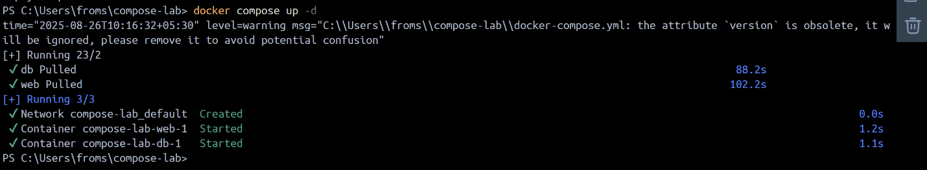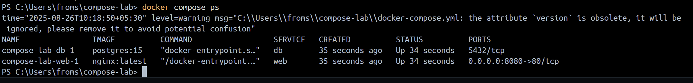

Step 2: Write and Interpret docker-compose.yml Files
- Modified docker-compose.yml
- Added Redis service
- Used depends_on for web → redis
- Ran docker compose up -d again
- Verified 3 services (web, db, redis) running

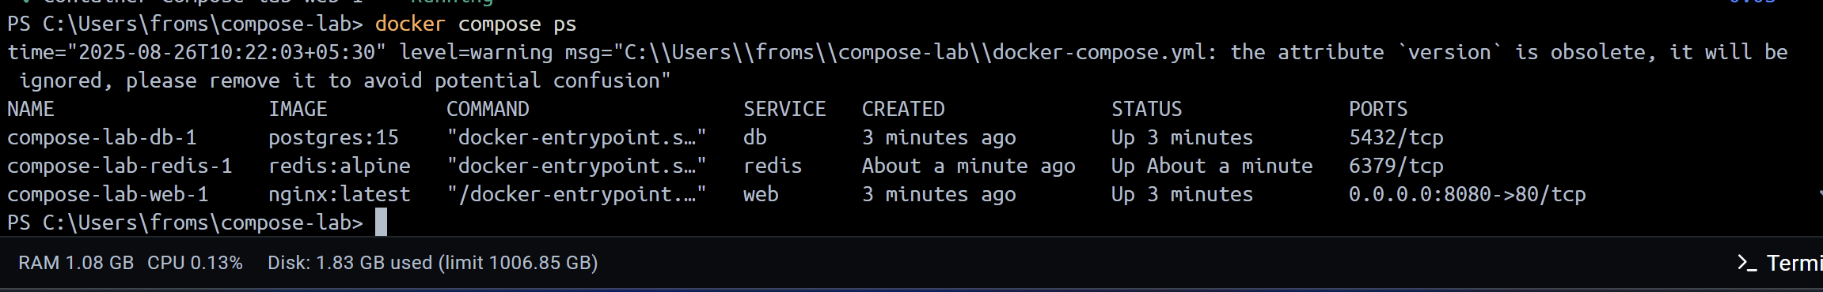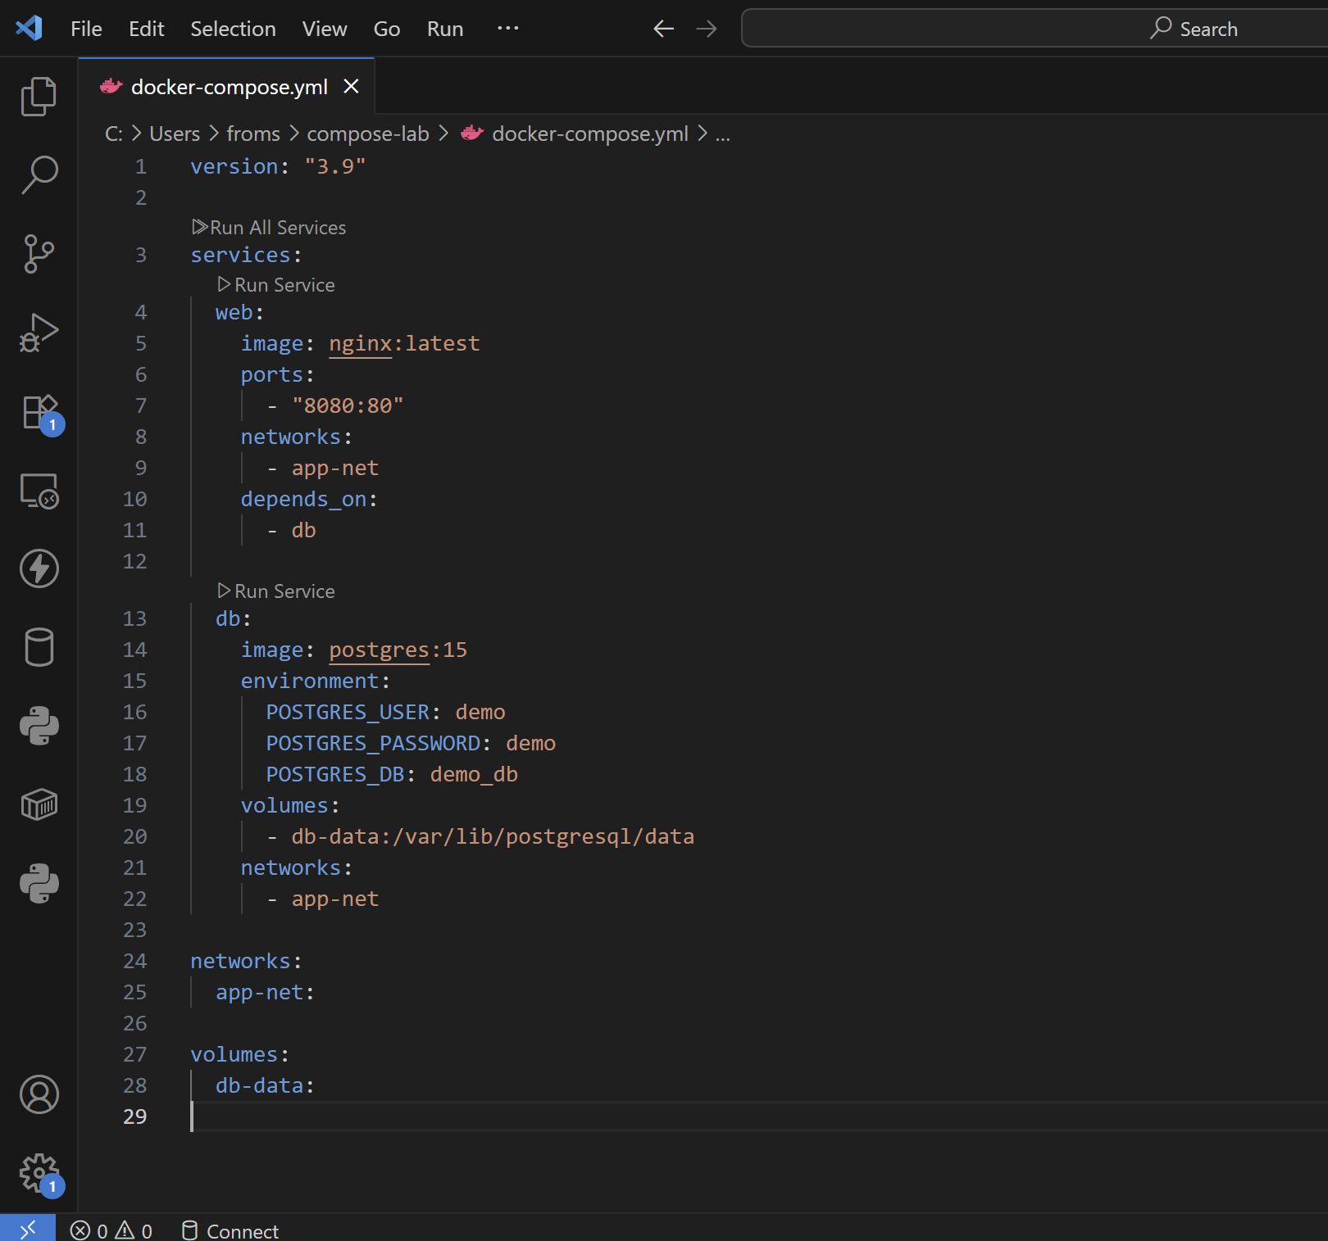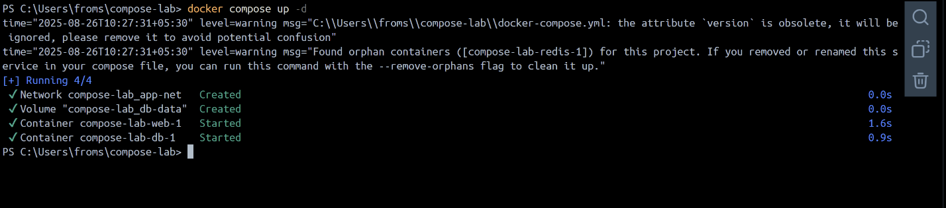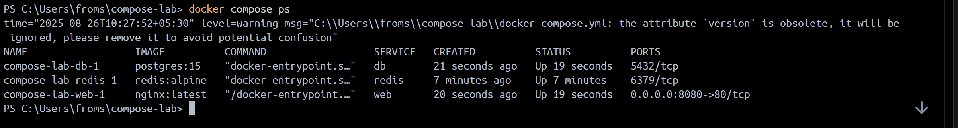
Step 3: Deploy Across Different Machines
- Zipped the compose-lab folder → compose-lab.zip
- Transferred to another machine
- Extracted and ran docker compose up -d
- Verified same services (nginx + postgres + redis) work on new machine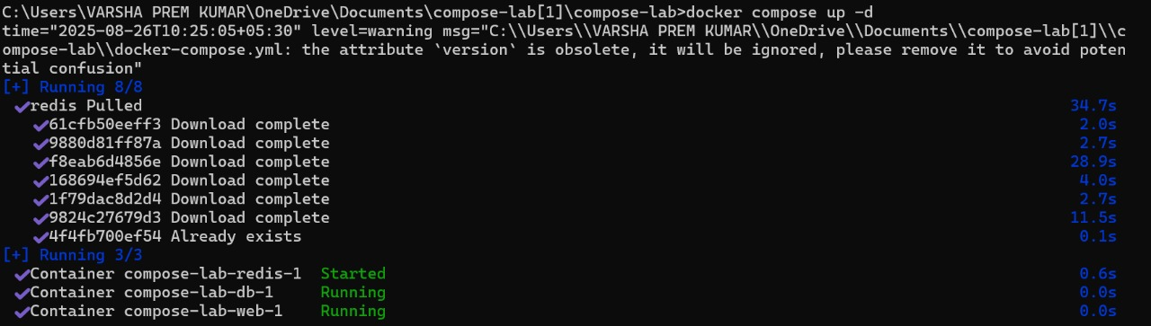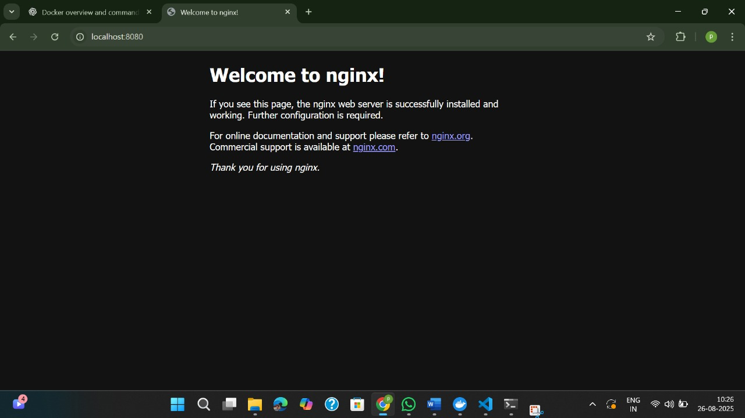
Step 4: Networking and Persistent Storage
- Updated docker-compose.yml to add:
  - Custom network app-net
  - Persistent volume db-data for Postgres
- Started services → verified network + volume creation
- Connected to Postgres (psql)
- Created students table and inserted sample data (Alice, Bob, Charlie)
- Stopped containers (docker compose down) and restarted (docker compose up -d)
- Verified data persistence with SELECT * FROM students;

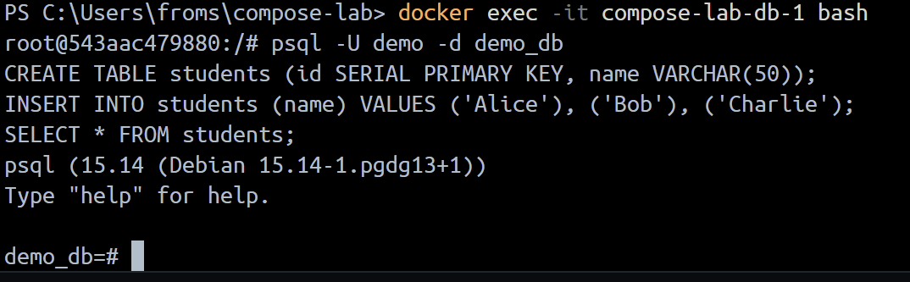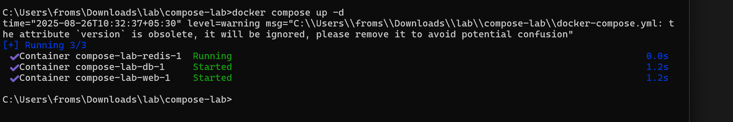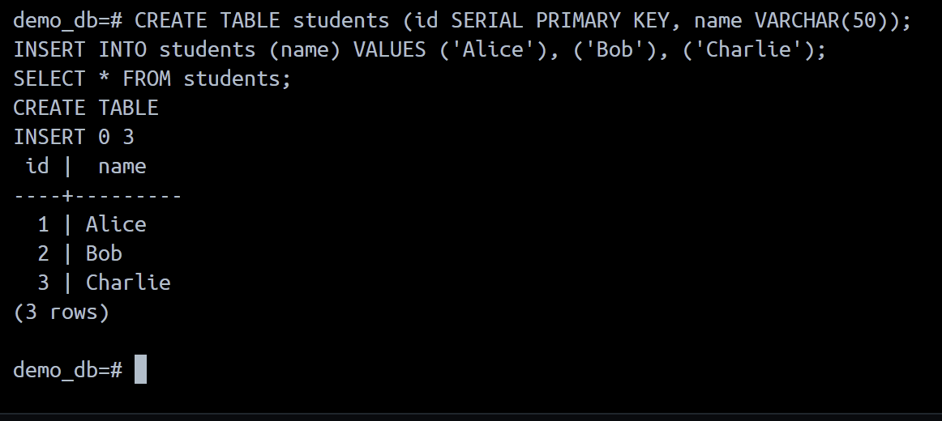
Step 5: Faster Iteration During Development (Flask App + Docker)
- Created Flask app (app.py)
- Created Dockerfile for Flask
- Updated docker-compose.yml to build web service from Dockerfile
- Ran docker compose up --build
- Opened http://localhost:5000 → “Hello from Flask + Docker!”
- Edited app.py → rebuilt → verified updated message immediately

